CardMarket reports from Power BI

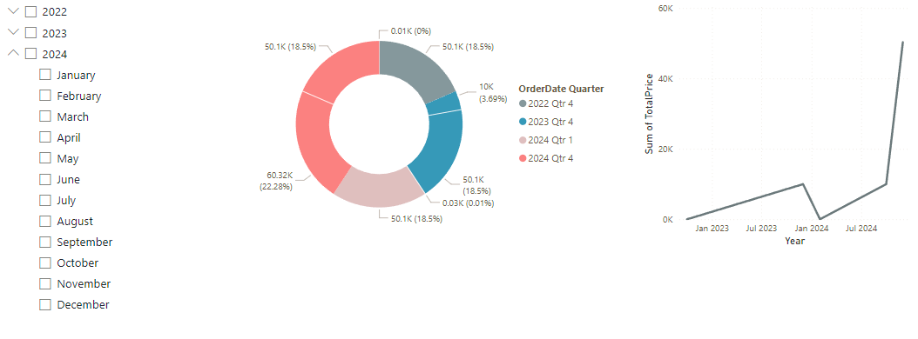

Choose Year and/or Month



Pie Chart of the TotalPrice by Year



TotalPrice Throughout the Years

Example for \*2024 February\*

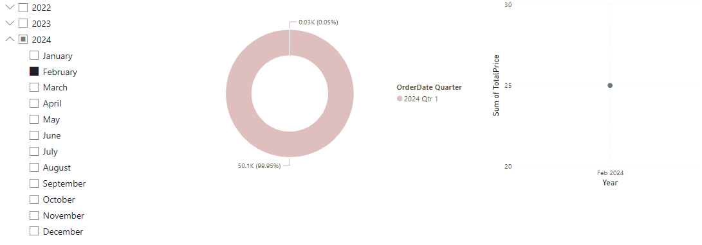

2024 February



Pie Chart of the TotalPrice in 2024 February



TotalPrice in 2024 February

Card Price Distribution

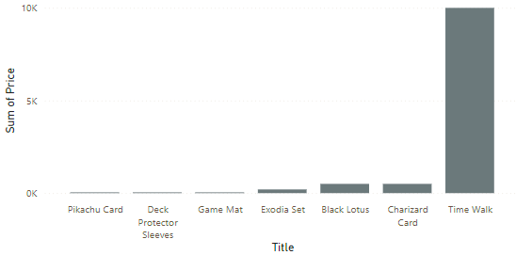

Display for Cards and their Prices